UCS 1611 - Internet Programming Lab **Exercise 2:** Website for International Conference using HTML5 and CSS3

**Swetha Saseendran**

**CSE-C**

**185001183**

**Learning objective:**

Develop a Website for an International Conference using HTML5 and Cascading Style Sheets.

Use the website you designed using HTML5.

**Specifications:**

While designing the web page:

1. Use Inline, Embedded, External Style Sheets.

2. Use box model, outline concepts.

3. CSS concepts with table, list, links, forms, anchor etc.

4. Write rules with rule cascading and inheritance.

5. Include Tooltip, Icons, Graphics, Animations, and Transformations.

**Note:** To design the website in a neat presentable, attractive manner.

**Code- Home Page:**

<!DOCTYPE html>

<html>

<head>

<title>International Conference</title>

<!-- ICONS -->

<link rel="stylesheet" href="https://cdnjs.cloudflare.com/ajax/libs/font-awesome/4.7.0/css/font-awesome.min.css">

<!-- FONT LINKS -->

<link rel="preconnect" href="https://fonts.gstatic.com">

<link href="https://fonts.googleapis.com/css2?family=Bree+Serif&family=Pacifico&display=swap" rel="stylesheet">

<!-- CSS FILE -->

<link rel="stylesheet" href="style.css">

<!-- FAVTION -->

<link rel="icon" href="fav.png" sizes="32x32">

<style>

body{**font-family**: "Bree Serif", **serif**;}

</style>

</head>

<body>

<nav>

<a href="index.html" style="background-color: #534caf;">Home</a>

<a href="commitee.html">Commitee</a>

<a href="call.html">Call For Papers</a>

<a href="imp.html">Important Dates</a>

<a href="workshop.html">Workshops</a>

<a href="registration.html">Register</a>

<a href="contact.html">Contact Us</a>

</nav>

<header>

<img src="header.PNG">

</header>

<marquee style="margin:10px;"> <h3> Marquee Text: The conference footer would appear on all pages. The text is as follows, on a single centred line: 2019 International Conference on Indoor Positioning and Indoor Navigation (IPIN), 30 Sept. - 3 Oct. 2019, Pisa, Italy</h3></marquee>

<div class="element">

</div>

<div style="margin: 40px; margin-left: 55px;">

<h1 style="z-index:1;">ABOUT US</h1>

</div>

<article class="container">

<section>

<p>International Conference Alerts provides details about the upcoming academic conferences, seminars and workshops to be held worldwide. Academician and professionals can get their relevant updates and conference alerts through International conference alerts. International Conference Alerts provides a free subscription to its users with email notifications about upcoming Medical conferences, Engineering conferences, Business and Economics, Science and education and various conferences. Users can register and subscribe to get free conference alerts regarding upcoming international conferences 2021 at Dubai, Germany, Singapore, Thailand, USA as well as all major cities and countries across the world. This is the exact reason why internationalconferencealerts.com was established - to provide the masses, up-to-date and incredibly reliable information on all upcoming conferences, in a variety of fields.</p>

</section>

<section>

<p>Many prominent and successful researchers, scientists and scholars have attributed their success to international conferences that they attended early on in their careers. They cited the great learning, networking, and collaborative opportunities that these conferences present, as being the reason for their success. International Conference Alerts offers conference organizers/planners the provision to better target potential conference delegates by allowing them to add details about their upcoming events to our existing conference listings. Numerous conference organizers and planners have witnessed remarkable growth in attendance at their events, after posting information about these events on our website! So take advantage of these provisions and expand your career or learn more about the latest developments in your field, today.</p>

</section>

</article>

<div class="wrap">

<div class="cont">

<div class="box google" style="text-align:center;">

<i class="fa fa-google" style="margin-top:10px;"></i>

</div>

</div>

<div class="cont">

<div class="box facebook" style="text-align:center;">

<i class="fa fa-facebook" style="margin-top:10px;"></i>

</div>

</div>

<div class="cont">

<div class="box linkedin" style="text-align:center;">

<i class="fa fa-linkedin" style="margin-top:10px;"></i>

</div>

</div>

<div class="cont">

<div class="box twitter" style="text-align:center;">

<i class="fa fa-twitter" style="margin-top:10px;"></i>

</div>

</div>

<div class="cont">

<div class="box youtube" style="text-align:center;">

<i class="fa fa-youtube" style="margin-top:10px;"></i>

</div>

</div>

</div>

<footer>

<p align ="center" style="color: white;"> © Copyright All Rights Reserved 2021</p>

</footer>

</body>

</html>

**Code- Committee Page:**

<html>

<head>

<title>International Conference</title>

<!-- ICONS -->

<link rel="stylesheet" href="https://cdnjs.cloudflare.com/ajax/libs/font-awesome/4.7.0/css/font-awesome.min.css">

<!-- FONT LINKS -->

<link rel="preconnect" href="https://fonts.gstatic.com">

<link href="https://fonts.googleapis.com/css2?family=Bree+Serif&family=Pacifico&display=swap" rel="stylesheet">

<!-- CSS FILE -->

<link rel="stylesheet" href="style.css">

<!-- FAVTION -->

<link rel="icon" href="fav.png" sizes="32x32">

<style>

body{**font-family**: "Bree Serif", **serif**;}

</style>

</head>

<body>

<nav>

<a href="index.html">Home</a>

<a href="commitee.html" style="background-color: #534caf;">Commitee</a>

<a href="call.html">Call For Papers</a>

<a href="imp.html">Important Dates</a>

<a href="workshop.html">Workshops</a>

<a href="registration.html">Register</a>

<a href="contact.html">Contact Us</a>

</nav>

<header>

<img src="header.PNG" >

</header>

<div style="margin: 40px; margin-left: 55px;">

<h1>International Conference Committees</h1>

</div>

<div class="container">

<ol>

<li>11th International Meeting on DNA Computing (DNA11), London, June 2005 - Organizing Committee Chair.</li>

<li>10th International Meeting on DNA Computing (DNA10), Milano, Italy, June 2004 - Program Committee Member.</li>

<li>Descriptional Complexity of Formal Systems, DCFS 2004 - Program Committee Member.</li>

<li>U.S. Frontiers of Engineering 2003, (U.S. National Academy of Engineering), California, September 2003 - Organizing Committee Member.</li>

<li>Descriptional Complexity of Formal Systems, DCFS 2003, July 2003, Budapest, Hungary - Program Committee Member.</li>

<li>9th International Meeting on DNA-Based Computers (DNA9), June 2003, Madison, Wisconsin - Program Committee Member.</li>

<li>Genetic and Evolutionary Computation Conference, GECCO-2002, New York, July 2002 - Program Committee Member.</li>

<li>8th International Meeting on DNA-Based Computers (DNA8), Sapporo, Japan, June 2002 - Program Committee Member.</li>

<li>Fifth International Conference Developments in Language Theory, DLT 2001, Wien Austria, July 16-21, 2001 - Program Committee Member.</li>

<li>Congress on Evolutionary Computation (CEC2001) Seoul, Korea, May 27-30, 2001 - Organizing Committee Member.</li>

<li>7th International Meeting on DNA-Based Computers (DNA7), June 2001, Tampa, Florida - Program Committee Member.</li>

<li>SPIRE'2000 - String Processing and Information REtrieval, September 27 - 29, 2000, A Coruna, Spain - Program Committee Member.</li>

</ol>

</div>

<div class="wrap">

<div class="cont">

<div class="box google" style="text-align:center;">

<i class="fa fa-google" style="margin-top:10px;"></i>

</div>

</div>

<div class="cont">

<div class="box facebook" style="text-align:center;">

<i class="fa fa-facebook" style="margin-top:10px;"></i>

</div>

</div>

<div class="cont">

<div class="box linkedin" style="text-align:center;">

<i class="fa fa-linkedin" style="margin-top:10px;"></i>

</div>

</div>

<div class="cont">

<div class="box twitter" style="text-align:center;">

<i class="fa fa-twitter" style="margin-top:10px;"></i>

</div>

</div>

<div class="cont">

<div class="box youtube" style="text-align:center;">

<i class="fa fa-youtube" style="margin-top:10px;"></i>

</div>

</div>

</div>

<footer>

<p align ="center" style="color: white;"> © Copyright All Rights Reserved 2021</p>

</footer>

</body>

</html>

**Code- Call for Papers Page:**

<html>

<head>

<title>International Conference</title>

<!-- ICONS -->

<link rel="stylesheet" href="https://cdnjs.cloudflare.com/ajax/libs/font-awesome/4.7.0/css/font-awesome.min.css">

<!-- FONT LINKS -->

<link rel="preconnect" href="https://fonts.gstatic.com">

<link href="https://fonts.googleapis.com/css2?family=Bree+Serif&family=Pacifico&display=swap" rel="stylesheet">

<!-- CSS FILE -->

<link rel="stylesheet" href="style.css">

<!-- FAVTION -->

<link rel="icon" href="fav.png" sizes="32x32">

<style>

body{**font-family**: "Bree Serif", **serif**;}

</style>

</head>

<body>

<nav>

<a href="index.html">Home</a>

<a href="commitee.html">Commitee</a>

<a href="call.html"style="background-color: #534caf;">Call For Papers</a>

<a href="imp.html">Important Dates</a>

<a href="workshop.html">Workshops</a>

<a href="registration.html">Register</a>

<a href="contact.html">Contact Us</a>

</nav>

<header>

<img src="header.PNG">

</header>

<div style="margin: 40px; margin-left: 55px;">

<h1>Conference Call for Papers</h1>

</div>

<article class="container">

<p>The 3rd International Conference on Advanced Research in Social Sciences (ICARSS), March 11 – 14, 2021 in Oxford, United Kingdom, is the premier forum for the presentation of new advances and research results in education theory and practice.</p>

<p>This conference is a prestigious event, organized to provide an international platform for the academicians, researchers, managers, industrial participants and students to share their research findings with global experts. All full paper submissions will be peer reviewed and evaluated based on originality, technical and/or research depth, accuracy and relevance to conference call for papers.</p>

<a style="color:rgb(76, 76, 207);"><em>Submission Format</em></a><br>

Authors must follow the Springer LNCS formatting instructions. For camera-ready papers use Latex or Word style. Each paper will receive at least three reviews. At least one author of each accepted paper must register by the early registration date indicated on the conference website and present the paper.

</article>

<article class="sidebyside" style="clear:both">

<section class="left">

<aside>

<h3>Sociology</h3>

<ul>

<li>Aging</li>

<li>Applied Anthropology</li>

<li>Archaeology</li>

<li>Black Lives Matter</li>

<li>Elderly care</li>

<li>Child Research</li>

<li>Childhood Development & Schooling</li>

</ul>

</aside>

</section>

<section class="right">

<h2>Philosophy</h2>

<ul>

<li>Pragmatism</li>

<li>Realism</li>

<li>Romanticism</li>

<li>Social Philosophy</li>

<li>Transcendentalism</li>

<li>Utilitarianism</li>

<li>Western Philosophy</li>

</ul>

</section>

<br>

</article>

<article style="clear:both;">

<section class="left">

<h2>Politics</h2>

<ul>

<li>Congressional Review Act</li>

<li>Debates</li>

<li>Democracy and Democratization</li>

<li>Donald Trump</li>

<li>Environmental Protection Agency</li>

<li>Executive power</li>

<li>Facebook campaigning</li>

<li>Governmental Systems & Practices</li>

</ul>

</section>

<section class="right">

<h2>Law</h2>

<ul>

<li>Forensic genealogy</li>

<li>Fraud</li>

<li>Geneva Conventions</li>

<li>Hate crime</li>

<li>Hate groups</li>

<li>Identity theft</li>

<li>Illegal drug use</li>

<li>Human Right Law</li>

</ul>

</section>

<br>

</article>

<br><br><br><br><br><br><br><br><br><br><br><br>

<br><br><br><br><br><br><br><br><br><br><br><br>

<div class="wrap">

<div class="cont">

<div class="box google" style="text-align:center;">

<i class="fa fa-google" style="margin-top:10px;"></i>

</div>

</div>

<div class="cont">

<div class="box facebook" style="text-align:center;">

<i class="fa fa-facebook" style="margin-top:10px;"></i>

</div>

</div>

<div class="cont">

<div class="box linkedin" style="text-align:center;">

<i class="fa fa-linkedin" style="margin-top:10px;"></i>

</div>

</div>

<div class="cont">

<div class="box twitter" style="text-align:center;">

<i class="fa fa-twitter" style="margin-top:10px;"></i>

</div>

</div>

<div class="cont">

<div class="box youtube" style="text-align:center;">

<i class="fa fa-youtube" style="margin-top:10px;"></i>

</div>

</div>

</div>

<footer>

<p align ="center" style="color: white;"> © Copyright All Rights Reserved 2021</p>

<div style="margin-left:560px; background-color: white; width: fit-content;">

</footer>

</body>

</html>

**Code- Important Dates**

<html>

<head>

<title>International Conference</title>

<!-- ICONS -->

<link rel="stylesheet" href="https://cdnjs.cloudflare.com/ajax/libs/font-awesome/4.7.0/css/font-awesome.min.css">

<!-- FONT LINKS -->

<link rel="preconnect" href="https://fonts.gstatic.com">

<link href="https://fonts.googleapis.com/css2?family=Bree+Serif&family=Pacifico&display=swap" rel="stylesheet">

<!-- CSS FILE -->

<link rel="stylesheet" href="style.css">

<!-- FAVTION -->

<link rel="icon" href="fav.png" sizes="32x32">

<style>

body{**font-family**: "Bree Serif", **serif**;}

</style>

</head>

<body>

<nav>

<a href="index.html">Home</a>

<a href="commitee.html">Commitee</a>

<a href="call.html">Call For Papers</a>

<a href="imp.html" style="background-color: #534caf;">Important Dates</a>

<a href="workshop.html">Workshops</a>

<a href="registration.html">Register</a>

<a href="contact.html">Contact Us</a>

</nav>

<header>

<img src="header.PNG">

</header>

<div style="margin: 40px; margin-left: 55px;">

<h1>Dates of Importance</h1>

</div>

<article class="container">

<table>

<thead style="font-size:25px;">

<tr>

<th>Event</th>

<th>Date</th>

</tr>

</thead>

<tbody>

<tr>

<td>Paper Submission Opens</td>

<td ><strong>December 01, 2020</strong></td>

</tr>

<tr>

<td>Paper Submission Closes:</td>

<td>

<strong>January 31, 2021</strong></p>

</td>

</tr>

<tr>

<td >Acceptance Notification</td>

<td ><strong>February 15, 2021</strong></td>

</tr>

<tr>

<td >Camera Ready Submission**&nbsp;**</td>

<td ><strong>March 10, 2021</strong></td>

</tr>

<tr>

<td >Pre Conference Workshop**&nbsp;**</td>

<td ><strong>March 18, 2021</strong></td>

</tr>

<tr>

<td >Conference</td>

<td ><strong>**&nbsp;**March 18,19 and 20, 2021</strong></td>

</tr>

</tbody>

</table>

</article>

<div class="wrap">

<div class="cont">

<div class="box google" style="text-align:center;">

<i class="fa fa-google" style="margin-top:10px;"></i>

</div>

</div>

<div class="cont">

<div class="box facebook" style="text-align:center;">

<i class="fa fa-facebook" style="margin-top:10px;"></i>

</div>

</div>

<div class="cont">

<div class="box linkedin" style="text-align:center;">

<i class="fa fa-linkedin" style="margin-top:10px;"></i>

</div>

</div>

<div class="cont">

<div class="box twitter" style="text-align:center;">

<i class="fa fa-twitter" style="margin-top:10px;"></i>

</div>

</div>

<div class="cont">

<div class="box youtube" style="text-align:center;">

<i class="fa fa-youtube" style="margin-top:10px;"></i>

</div>

</div>

</div>

<footer>

<p align ="center" style="color: white;"> © Copyright All Rights Reserved 2021</p>

</footer>

</body>

</html>

**Code- Workshop:**

<!DOCTYPE html>

<html>

<head>

<title>International Conference</title>

<!-- ICONS -->

<link rel="stylesheet" href="https://cdnjs.cloudflare.com/ajax/libs/font-awesome/4.7.0/css/font-awesome.min.css">

<!-- FONT LINKS -->

<link rel="preconnect" href="https://fonts.gstatic.com">

<link href="https://fonts.googleapis.com/css2?family=Bree+Serif&family=Pacifico&display=swap" rel="stylesheet">

<!-- CSS FILE -->

<link rel="stylesheet" href="style.css">

<!-- FAVTION -->

<link rel="icon" href="fav.png" sizes="32x32">

<style>

body{

**font-family**: "Bree Serif", **serif**;

}

**.imp**{

**display**: flex;

**margin**: **auto**;

**justify**-**content**: **center**;

box-shadow: **0** **4px** **8px** **0** rgba(**0**, **0**, **0**, **0**.**3**);

transition: **0.3s**;

**border**-radius: **15px**;

**background-color**:white;

**padding-left**:**20px**;

**width**:**200px**;

**height**:**200px**;

}

</style>

</head>

<body>

<nav>

<a href="index.html">Home</a>

<a href="commitee.html"">Commitee</a>

<a href="call.html">Call For Papers</a>

<a href="imp.html">Important Dates</a>

<a href="workshop.html" style="background-color: #534caf;">Workshops</a>

<a href="registration.html">Register</a>

<a href="contact.html">Contact Us</a>

</nav>

<header>

<img src="header.PNG">

</header>

<div style="margin: 40px; margin-left: 55px;">

<h1>Pre-Conference Workshops</h1>

</div>

<article class="container">

<section style="display:table-cell; vertical-align:top; float:left;">

<h3>SUNDAY, 07 JUNE 2020 - ON-DEMAND</h3>

<ol>

<li>WS-01: Workshop on Integrating UAVs into 5G and Beyond</li>

<li>WS-02: Workshop on Convergent IoT (C-IoT)</li>

<li>WS-04: Workshop on 5G LTE and Intelligent Communications</li>

<li>WS-05: Workshop on V2X Technologies for Next Generation Driving Paradigm</li>

<li>WS-06: SecSDN: Secure and Dependable Software</li>

</ol>

</section>

<div classstyle="display:table-cell;float:right;">

<img src="img.PNG" class="imp"/>

</div>

<section style="display:table-cell; vertical-align:top; float:right;">

<h3>THURSDAY, 11 JUNE 2020 - ON-DEMAND</h3>

<ol>

<li>WS-01: Workshop on Integrating UAVs into 5G and Beyond</li>

<li>WS-02: Workshop on Convergent IoT (C-IoT)</li>

<li>WS-04: Workshop on 5G LTE and Intelligent Communications</li>

<li>WS-05: Workshop on V2X Technologies for Next Generation Driving Paradigm</li>

<li>WS-06: SecSDN: Secure and Dependable Software </li>

</ol>

</section>

<div classstyle="display:table-cell;float:left;">

<img src="work.jpg" class="imp"/>

</div>

</article>

<div class="wrap">

<div class="cont">

<div class="box google" style="text-align:center;">

<i class="fa fa-google" style="margin-top:10px;"></i>

</div>

</div>

<div class="cont">

<div class="box facebook" style="text-align:center;">

<i class="fa fa-facebook" style="margin-top:10px;"></i>

</div>

</div>

<div class="cont">

<div class="box linkedin" style="text-align:center;">

<i class="fa fa-linkedin" style="margin-top:10px;"></i>

</div>

</div>

<div class="cont">

<div class="box twitter" style="text-align:center;">

<i class="fa fa-twitter" style="margin-top:10px;"></i>

</div>

</div>

<div class="cont">

<div class="box youtube" style="text-align:center;">

<i class="fa fa-youtube" style="margin-top:10px;"></i>

</div>

</div>

</div>

<footer>

<p align ="center" style="color: white;"> © Copyright All Rights Reserved 2021</p>

</footer>

</div>

</body>

</html>

**Code- Registration Page:**

<!DOCTYPE html>

<html>

<head>

<title>International Conference</title>

<!-- ICONS -->

<link rel="stylesheet" href="https://cdnjs.cloudflare.com/ajax/libs/font-awesome/4.7.0/css/font-awesome.min.css">

<!-- FONT LINKS -->

<link rel="preconnect" href="https://fonts.gstatic.com">

<link href="https://fonts.googleapis.com/css2?family=Bree+Serif&family=Pacifico&display=swap" rel="stylesheet">

<!-- CSS FILE -->

<link rel="stylesheet" href="style.css">

<!-- FAVTION -->

<link rel="icon" href="fav.png" sizes="32x32">

<style>

body{

**font-family**: "Bree Serif", **serif**;

}

**.form**{

**display**: flex;

**margin**: **auto**;

**justify**-**content**: **center**;

**width**: **40**%;

**height**: **550px**;

box-shadow: **0** **4px** **8px** **0** rgba(**0**, **0**, **0**, **0**.**3**);

transition: **0.3s**;

**border**-radius: **15px**;

**background-color**:white;

}

**#regs**{

**padding**: **20px**;

**display**: flex;

flex-**direction**: column

}

</style>

</head>

<body>

<nav>

<a href="index.html">Home</a>

<a href="commitee.html">Commitee</a>

<a href="call.html">Call For Papers</a>

<a href="imp.html">Important Dates</a>

<a href="workshop.html">Workshops</a>

<a href="registration.html" style="background-color: #534caf;">Register</a>

<a href="contact.html">Contact Us</a>

</nav>

<header>

<img src="header.PNG">

</header>

<div style="margin: 40px; margin-left: 55px;">

<h1>Register Now!</h1>

</div>

<section class="container">

<p>

The registration fee for different categories of participants is mentioned in the table below. The registration fee for main conference with workshop will cover conference & workshop, full access to all sessions/invited talks including the pre-conference workshop.

</p>

<p>

Currently the only possible mode of payment is NEFT/RTGS for Indian participants and wire transfer for foreign participants. The required bank details are mentioned below:

</p>

<ul>

<li>Bank Account Holders Name :: The Principal SSN College of Engineering</li>

<li>Bank A/c Name (NEFT/RTGS/E-Payment) :: 158100050070022</li>

<li>Bank Name :: Tamilnad Mercantile Bank</li>

<li>IFSC/MICR Code :: TMBL0000158 / 600060010</li>

<li>Swift Code :: TMBLINBBCHE</li>

</ul>

</section>

<section class="container" style="padding-top:20px;">

<h2 style="text-align: center; margin-bottom: 20px">

REGISTER NOW!

</h2>

<section class="form">

<form id="regs" action="#">

<label for="name">Name</label>

<input class="form-input" type="text" id="name"/><br/>

<br />

<label for="email">Email ID</label>

<input class="form-input" type="text" id="email"/><br/>

<label for="phone">Contact</label>

<input class="form-input" type="text" style="width:70%" id="phone"/><br/>

<div class="horizontal-group">

<label class="label-title">Gender</label>

<select class="form-input" id="level" style="width:40%;">

<option value="B">Male</option>

<option value="I">Female</option>

<option value="A">Other</option>

</select>

</div>

<div class="form-group">

<label for="choose-file" class="label-title">Write to us</label>

<textarea class="form-input" rows="4" cols="50" style="height:auto"></textarea>

</div>

</div>

<input type="submit" value="Register" class= "btn"

/><br />

</form>

</section>

</section>

<div class="wrap">

<div class="cont">

<div class="box google" style="text-align:center;">

<i class="fa fa-google" style="margin-top:10px;"></i>

</div>

</div>

<div class="cont">

<div class="box facebook" style="text-align:center;">

<i class="fa fa-facebook" style="margin-top:10px;"></i>

</div>

</div>

<div class="cont">

<div class="box linkedin" style="text-align:center;">

<i class="fa fa-linkedin" style="margin-top:10px;"></i>

</div>

</div>

<div class="cont">

<div class="box twitter" style="text-align:center;">

<i class="fa fa-twitter" style="margin-top:10px;"></i>

</div>

</div>

<div class="cont">

<div class="box youtube" style="text-align:center;">

<i class="fa fa-youtube" style="margin-top:10px;"></i>

</div>

</div>

</div>

<footer>

<p align ="center" style="color: white;"> © Copyright All Rights Reserved 2021</p>

</footer>

</body>

</html>

**Code- Contact Us Page:**

<!DOCTYPE html>

<html>

<head>

<title>International Conference</title>

<!-- ICONS -->

<link rel="stylesheet" href="https://cdnjs.cloudflare.com/ajax/libs/font-awesome/4.7.0/css/font-awesome.min.css">

<!-- FONT LINKS -->

<link rel="preconnect" href="https://fonts.gstatic.com">

<link href="https://fonts.googleapis.com/css2?family=Bree+Serif&family=Pacifico&display=swap" rel="stylesheet">

<!-- CSS FILE -->

<link rel="stylesheet" href="style.css">

<!-- FAVTION -->

<link rel="icon" href="fav.png" sizes="32x32">

<style>

body{**font-family**: "Bree Serif", **serif**;}

</style>

</head>

<body>

<nav>

<a href="commitee.html">Home</a>

<a href="commitee.html">Commitee</a>

<a href="call.html">Call For Papers</a>

<a href="imp.html">Important Dates</a>

<a href="workshop.html"">Workshops</a>

<a href="registration.html">Register</a>

<a href="contact.html" style="background-color: #534caf;">Contact Us</a>

</nav>

<header>

<img src="header.PNG">

</header>

<div style="margin: 40px; margin-left: 55px;">

<h1>Contact Us:</h1>

</div>

<section class="container">

<div classstyle="display:table-cell;float:center;">

<img src="email.png" style="margin-left:48%;width:50px;height:50px;" />

</div>

<h2 style="color:#334467; text-align:center">Dr.S.Simon Corwell</h2>

<h4 style="text-align:center">simon_c45@gmail.com</h4>

<h2 style="color: #334467;text-align:center">Dr.Elizabeth Olsen</h2>

<h4 style="text-align:center">elle_ashley@gmail.com</h4>

<h2 style="color: #334467;text-align:center">Dr.Stark Banner</h2>

<h4 style="text-align:center">banner_stone78@gmail.com</h4>

<a href="mailto: swethasaseendran4@gmail.com" style="margin-left:0px;color:black;">Contact Admin</a>

</section>

<div class="wrap">

<div class="cont">

<div class="box google" style="text-align:center;">

<i class="fa fa-google" style="margin-top:10px;"></i>

</div>

</div>

<div class="cont">

<div class="box facebook" style="text-align:center;">

<i class="fa fa-facebook" style="margin-top:10px;"></i>

</div>

</div>

<div class="cont">

<div class="box linkedin" style="text-align:center;">

<i class="fa fa-linkedin" style="margin-top:10px;"></i>

</div>

</div>

<div class="cont">

<div class="box twitter" style="text-align:center;">

<i class="fa fa-twitter" style="margin-top:10px;"></i>

</div>

</div>

<div class="cont">

<div class="box youtube" style="text-align:center;">

<i class="fa fa-youtube" style="margin-top:10px;"></i>

</div>

</div>

</div>

<footer>

<p align ="center" style="color: white;"> © Copyright All Rights Reserved 2021</p>

</footer>

</body>

</html>

**CSS File:**

/* Main Header */

nav{

**background-color**: **#334467**;

**overflow**: **hidden**;

**border**-radius: **20px**;

**position**: **fixed**;

}

header img

{

**margin-top**: **50px**;

**width**: **100**%;

**height**: **200px**;

**border**-radius: **15px**;

}

a{

**float**: **left**;

**display**: **block**;

**text-align**: **center**;

**padding**: **14px** **16px**;

**font-size**: **17px**;

**text-decoration**: **none**;

**color**: white;

}

nav a**:hover** {**background-color**: **rgb**(**70**, **64**, **71**);}

/* Body Content */

h1,h2,h3{

**color**:**rgb**(**127**, **127**, **206**);

}

**.container**{

**margin**: **30px**;

**background-color**:**#f1f1f1**;

**padding-top**: **50px**;

**padding-right**: **30px**;

**padding-bottom**: **50px**;

**padding-left**: **80px**;

**border**-radius: **15px**;

}

/* List */

**.left**{

**float**:**left**;

**margin-left**:**150px**;

**width**: **300px**;

}

**.right**{

**float**:**right**;

**margin-right**:**250px**;

**width**: **300px**;

}

li**:hover**{

**font-size**:**20px**;

}

ul> li {

**margin-top**: **10px**;

**list-style**: "🔁 ";

**list-style-position**: **outside**;

}

ul {

**border**: **2px** **solid** **#ddd**;

**width**:**70**%;

**border**-radius: **15px**;

}

li {

**margin**: **5px**;

**background-color**: **rgb**(**245**, **224**, **255**);

}

**.sidebyside** li{

**width**: **200px**;

}

/* Table */

table{

**height**: **191px**;

**width**: **428px**;

**border**: **1px** **solid** **#ddd**;

**padding**: **8px**;

align-**content**: **center**;

**margin-left**: **auto**;

**margin-right**: **auto**;

}

thead{

**background-color**: **rgb**(**221**, **174**, **255**);

}

tr{

**padding-left**: **30px**;

}

td{

**width**: **201px**;

**padding-left**: **30px**;

**border**: **1px** **solid** **#ddd**;

**padding**: **8px**;

}

tbody tr**:hover** {

**background-color**: **rgb**(**222**, **210**, **228**);

**font-weight**: **900**;

**font**: **100**% system-ui;

}

tr**:nth-child**(even){**background-color**: **#f2f2f2**;}

/* Registration Form */

input[type=text], select, textarea{

**width**: **100**%;

**padding**: **12px**;

**border**: **1px** **solid** **#ccc**;

**border**-radius: **4px**;

box-sizing: **border**-box;

resize: vertical;

}

label {

**padding-right**:**10px**;

**display**: **inline**-**block**;

**width**:**20**%;

}

input[type=submit] {

**background-color**: **rgb**(**127**, **127**, **206**);

**color**: white;

**padding**: **12px** **20px**;

**border**: **none**;

**border**-radius: **4px**;

**cursor**: **pointer**;

**float**: **right**;

}

**.col-25** {

**float**: **left**;

**width**: **25**%;

**margin-top**: **6px**;

}

**.col-75** {

**float**: **left**;

**width**: **50**%;

**margin-top**: **6px**;

}

**.row:after** {

**content**: "";

**display**: table;

**clear**: **both**;

}

/* Footer*/

footer{

**background-color**: **#08202e**;

**padding-top**: **35px**;

**padding-bottom**: **35px**;

**font-weight**: **400**;

**font-size**: **17px**;

}

/*Icons*/

**.icon-bar** a {

**display**: **block**;

**text-align**: **center**;

**padding**: **16px**;

transition: all **0.3s** ease;

**color**: white;

**font-size**: **20px**;

}

**.icon-bar** a**:hover** {

**background-color**: **#000**;

}

**.facebook** {

**background**: **#3B5998**;

**color**: white;

}

**.twitter** {

**background**: **#55ACEE**;

**color**: white;

}

**.google** {

**background**: **#dd4b39**;

**color**: white;

}

**.linkedin** {

**background**: **#007bb5**;

**color**: white;

}

**.youtube** {

**background**: **#bb0000**;

**color**: white;

}

/* FORM */

**.signup-form** {

**font-family**: "Roboto", **sans-serif**;

**width**:**650px**;

**margin**:**30px** **auto**;

**border**-radius: **10px**;

}

**.form-header** {

**background-color**: **#EFF0F1**;

**border-top**-**left**-radius: **10px**;

**border-top**-**right**-radius: **10px**;

}

**.form-header** h1 {

**font-size**: **30px**;

**text-align**:**center**;

**color**:**#666**;

**padding**:**20px** **0**;

**border-bottom**:**1px** **solid** **#cccccc**;

}

**.form-body** {

**padding**:**10px** **40px**;

**color**:**#666**;

}

**.form-group**{

**margin-bottom**:**20px**;

**margin-top**:**20px**;

}

**.form-body** **.form-input** {

**font-size**: **17px**;

box-sizing: **border**-box;

**width**: **40**%;

**height**: **34px**;

**padding-left**: **10px**;

**padding-right**: **10px**;

**color**: **#333333**;

**text-align**: **left**;

**border**: **1px** **solid** **#d6d6d6**;

**border**-radius: **4px**;

**background**: white;

**outline**: **none**;

}

**.btn** {

**display**:**inline**-**block**;

**padding**:**10px** **20px**;

**background-color**: **rgb**(**127**, **127**, **206**);

**border**:**none**;

**color**: white;

**cursor**:**pointer**;

**outline**: **none**;**border**-radius: **25px**;

**font-size**: **1**rem;

**width**:**30**%;

**margin**:**auto**;

}

/* Transformation and Animation */

**.wrap** {

**margin**: **0px**;

**padding-left**: **40**%;

**display**: flex;

flex-flow: row wrap;

}

**.cont** {

**display**: **inline**-**block**;

**width**: **5**%;

**margin**:**10px**;

}

**.cont** h1 {

**color**: lightgray;

**font-family**: lato;

**font-size**: **1**rem;

**font-weight**: **200**;

**text-align**: **center**;

}

**.box** {

**border**-radius: **50**%;

**height**: **40px**;

**margin**: **30px** **auto**;

**width**: **40px**;

transition: all **300**ms;

**margin-right**:**30px**;

}

**.cont:hover** **.box** {

transform: scale(**2**);

}

**OUTPUT SCREENSHOTS:**

**HOME PAGE: (with marquee text after the header)**



**COMMITEE PAGE: (Enlarge text on hover)**

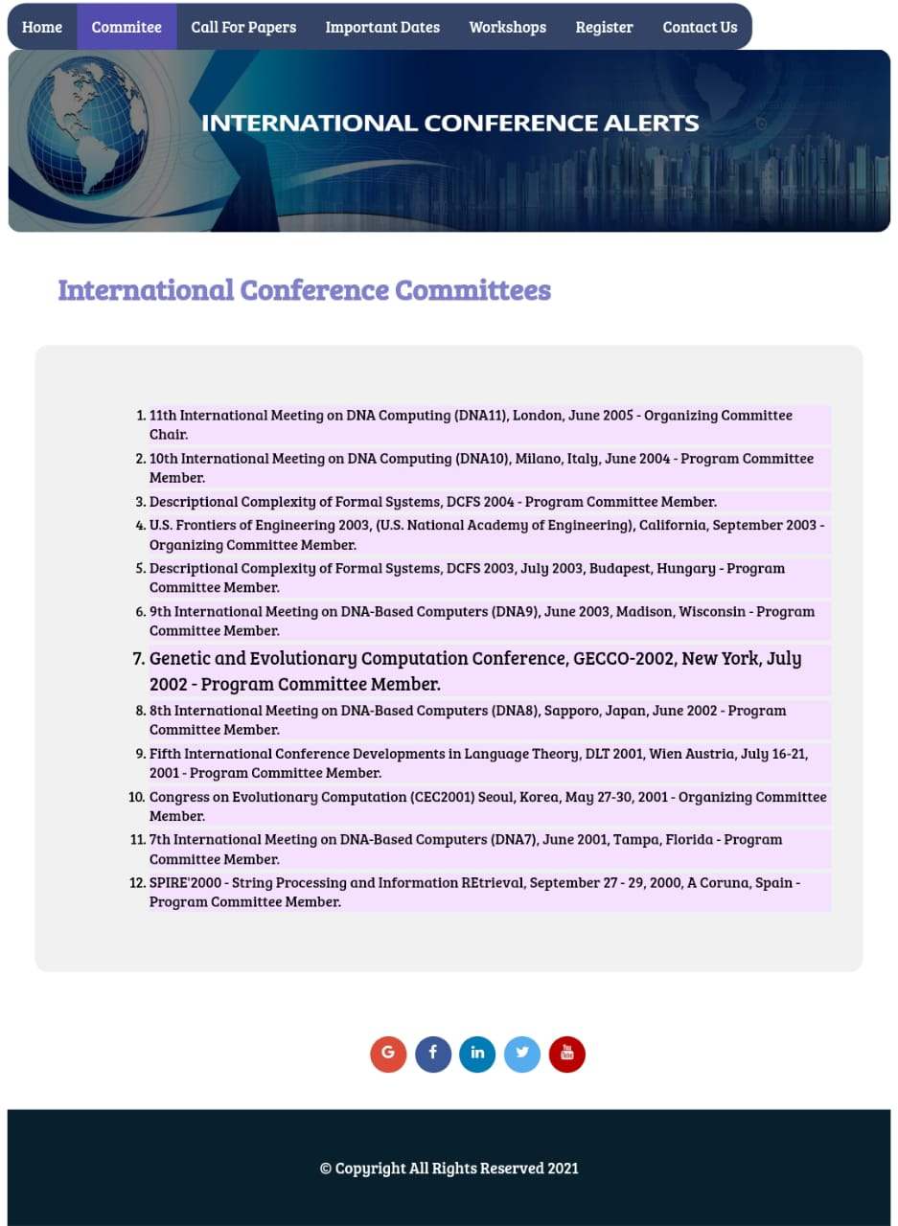

**CONFERENCE PAGE:**

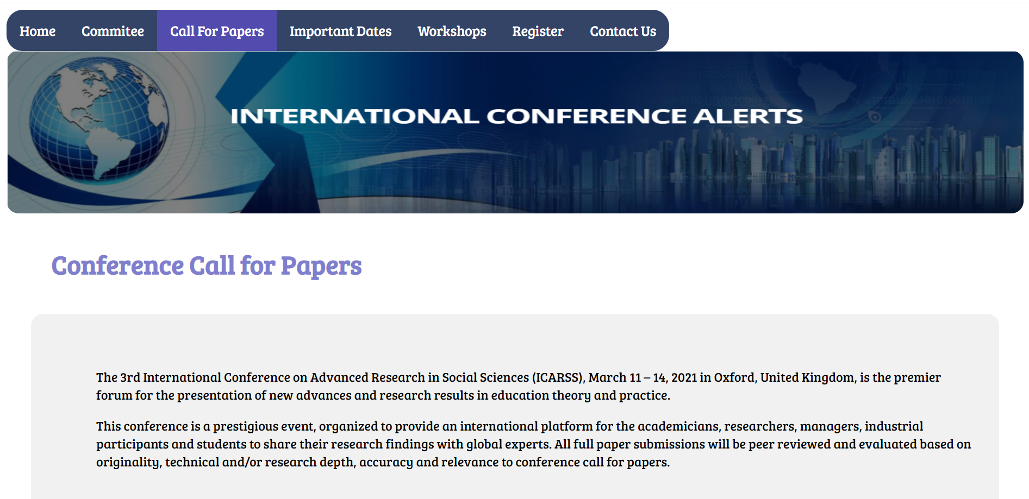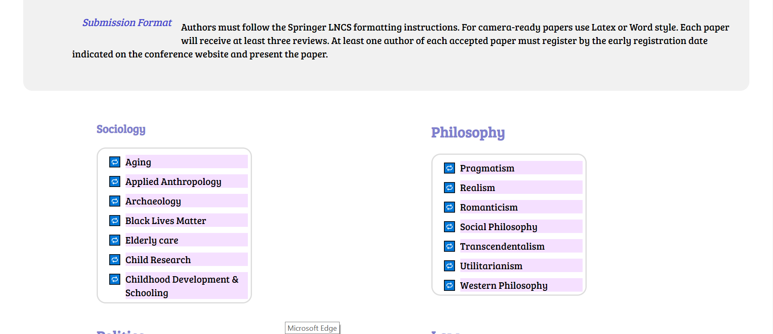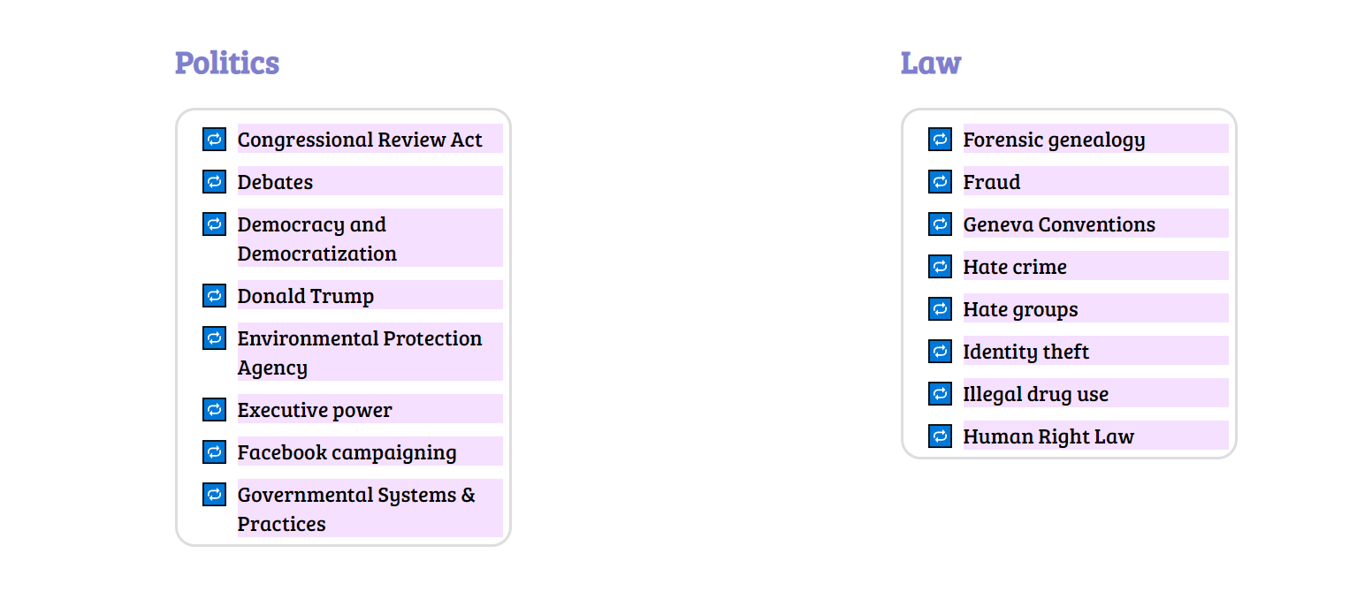

**DATES PAGE:** (Highlight and enlarge on hover) 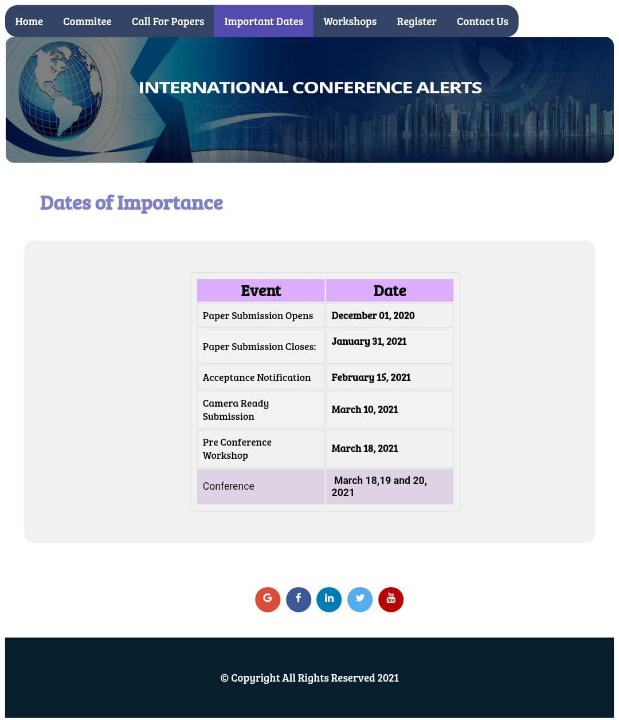

**WORKSHOPS PAGE:** (Enlarge on hover)

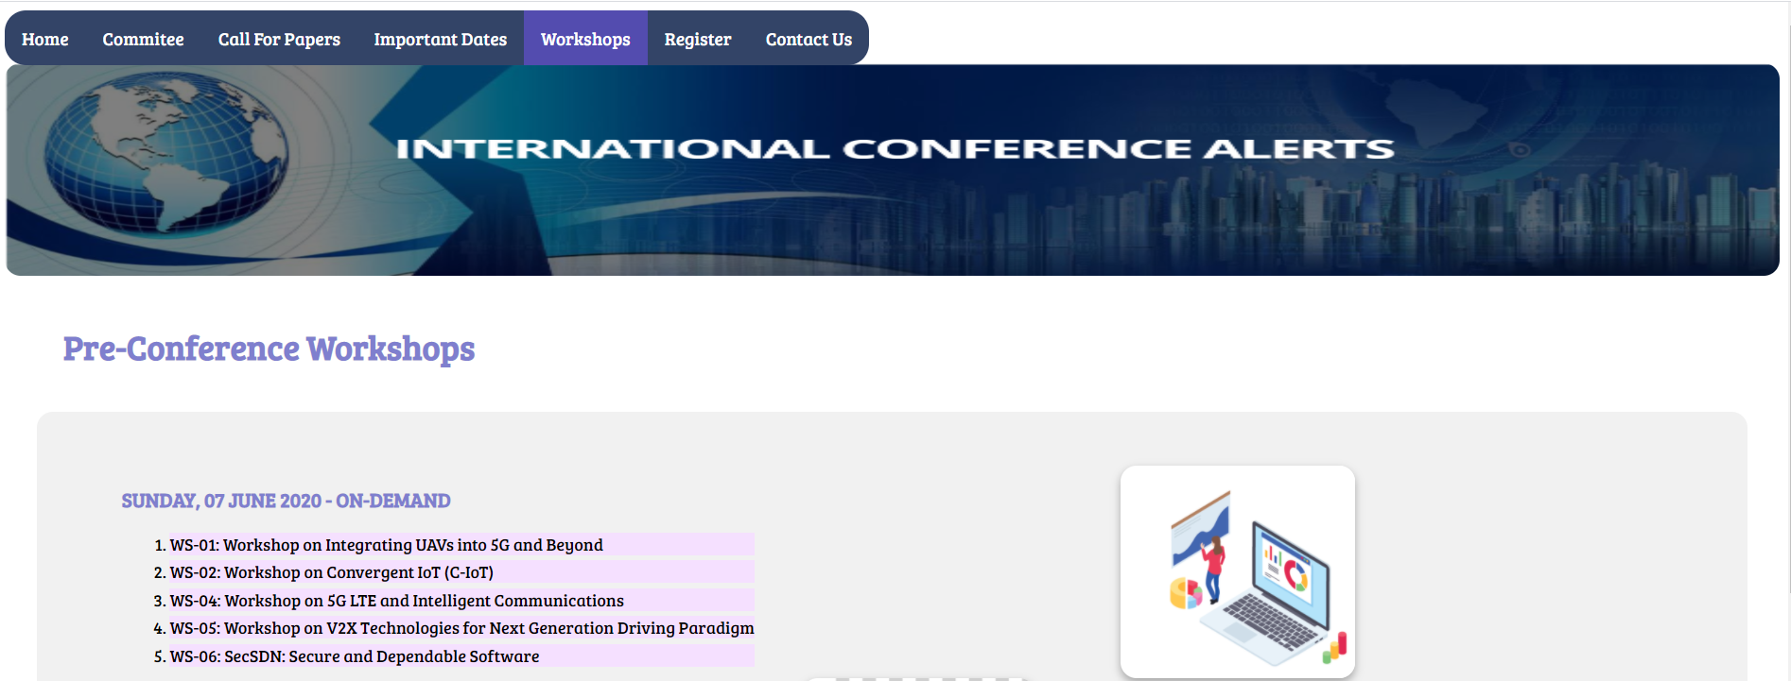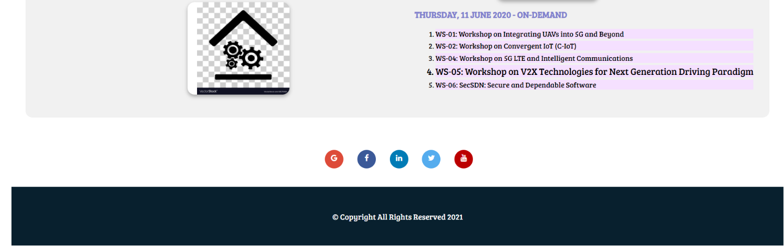

**REGISTER PAGE**

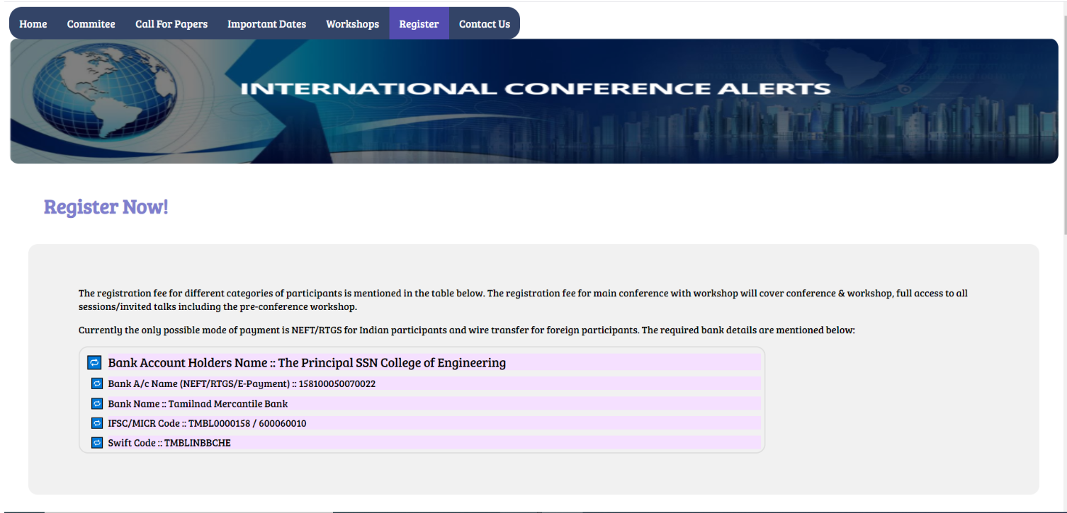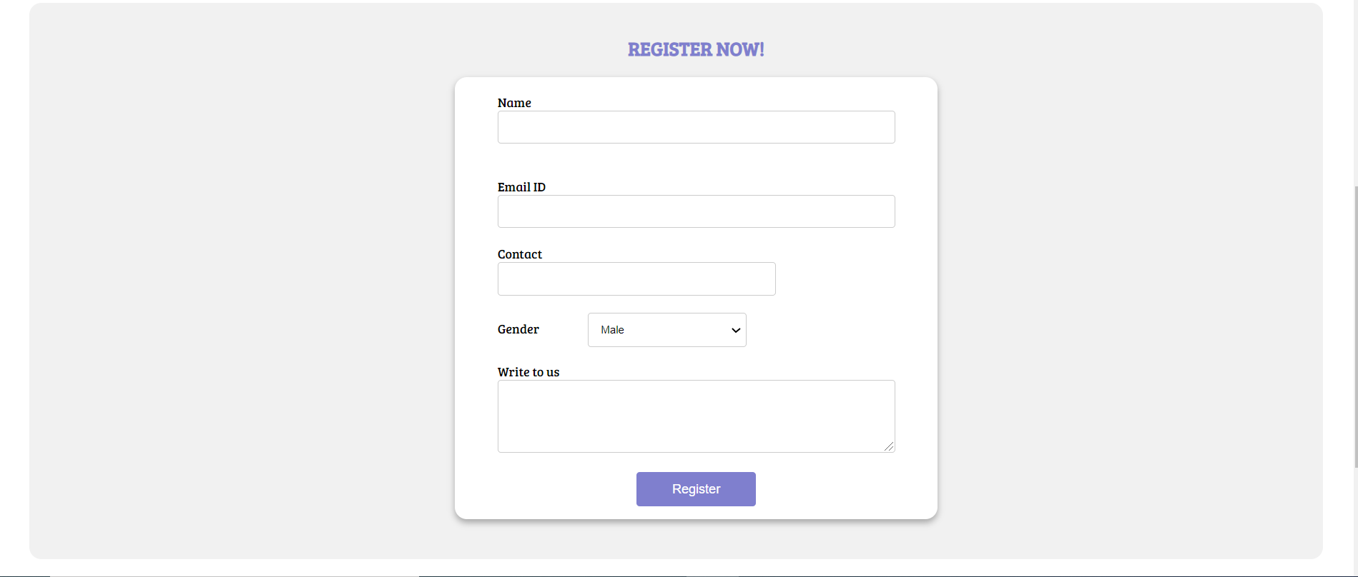

**CONTACT US PAGE:**

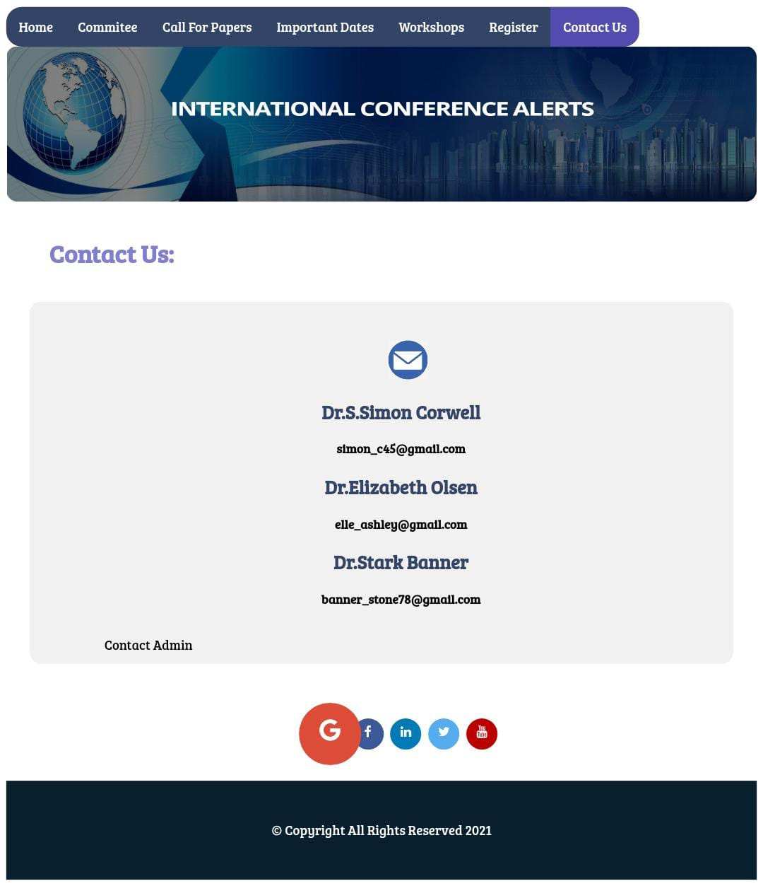

**SOME OTHER FEATURES IN ALL PAGES:**

1. Sticky Navbar and Transform Animation on social media icon on hover (For all pages):

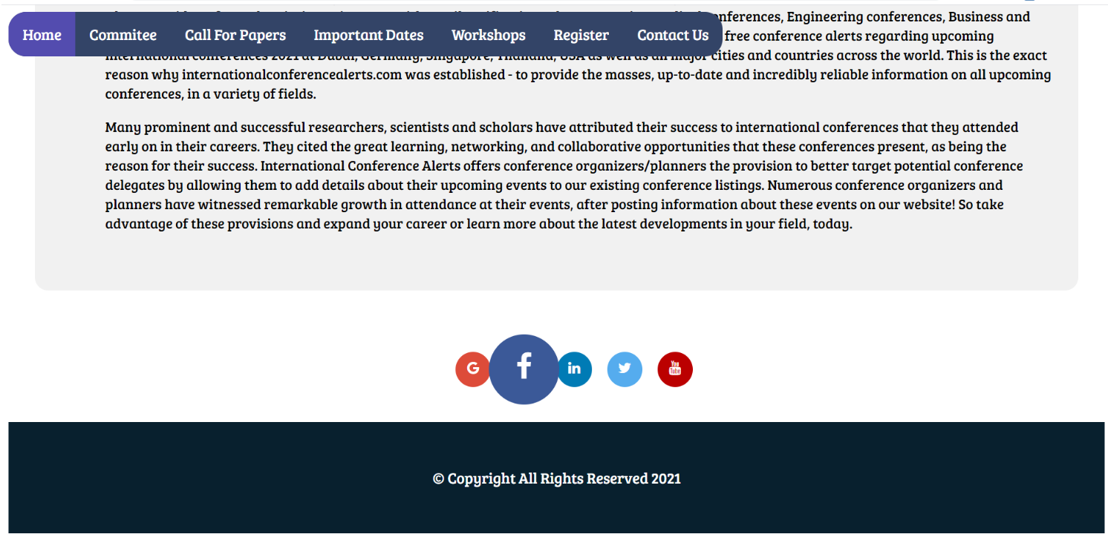

1. Highlight on hovering over the Navbar

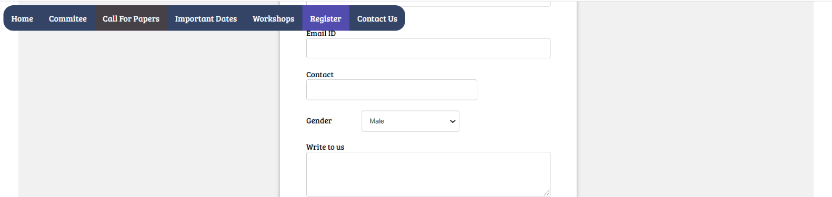

**LEARNING OUTCOME:**

* Learnt about the attributes for the HTML5 tags and CSS3 attributes, selectors and used it in the assignment.
* Learnt to become familiar with CSS design principles that relate to web design and learn how to implement them into practice.
* Understood that changing styles and redesigning pages is much more efficient with external CSS files since you only need to change these styles in one file instead of all your HTML files.
* Developed an understanding of how CSS can enhance the design of a webpage to create and apply CSS styling to a webpage and consider audience and purpose when developing CSS styles.
* Understood the usefulness of writing rules with rule cascading and inheritance.
* Learnt to use CSS concepts with table, list, links, forms, anchor etc. and to include Tooltip, Icons, Graphics, Animations, and Transformations.
* Learnt CSS grid layout and box-model.
* Understood the importance of making web pages accessible, well-formed and user friendly.